STAKEHOLDERS

IN SUPPLY CHAIN NETWORK: FARMING SECTOR OF INDIA

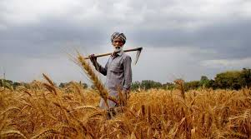

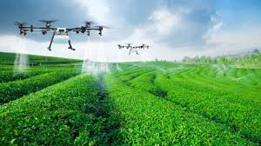

- By

Rayan Kejriwal

Contents

1. Abstract
2. Introduction
3. Objective

3.1 Agriculture supply chain system

3.2 ICT in Agriculture: A Major Stakeholder

4. Result

5. Conclusion

1. **Abstract**

The agricultural sector in India is one of the prominent sectors and contributes to almost 18% of India’s GDP and nearly half of the workforce of the country contributes to this sector. Agricultural commodities produced have to undergo a series of operations such as harvesting, threshing, winnowing, bagging, transportation, storage, processing, and exchange before they reach the market, and as evident from several studies across the country, there are considerable losses in crop output at all these stages. A recent estimate by the Ministry of Food and Civil Supplies, Government of India, puts the total preventable post-harvest losses of food grains at 10 percent of the total production or about 20 million Mt, which is equivalent to the total food grains produced in Australia annually. In a country where 20 percent of the population is undernourished, post-harvest losses of 20 million Mt annually is a substantial avoidable waste. According to a World Bank study (1999), post-harvest losses of food grains in India are 7-10 percent of the total production from farm to market level and 4-5 percent at market and distribution levels. These losses would be enough to feed about 70-100 million people, i.e. about 1/3rd of India's poor or the entire population of the states of the Bihar and Haryana together for about one year. Thus, it is evident that the post-harvest losses have an impact at both the micro and macro levels of the economy. This article critically reviews the scenario of agriculture supply chain management in India by throwing a light on the role of agriculture supply chain management, Agri-food supply chain management, and majorly highlights the contribution of ICT and modern technology in the development of farming sector. The report also concentrates on the advent of new startups and entrepreneurial firms and their role in the upcoming years of the agriculture sector in India as one of the major stakeholders.

1. **Introduction**

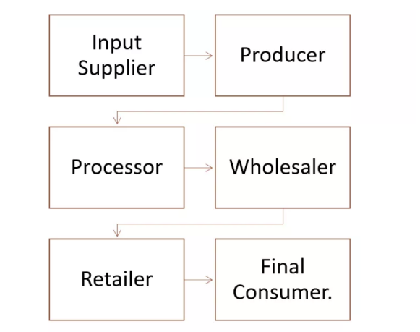Supply chain involves the flow of product which aims to reach the final consumer passing through various stages involving stakeholders such as producers, wholesalers, logistic services, transporters, warehouses, retailers, and finally consumers. In a broader sense, supply chains can also include product development, marketing, finance, and customer service.

In the farming sector, the main stakeholders

The most important role is played by the transport and logistics sector which create links between various departments involved in the whole business. They are the backbone of the industry who act as intermediates establishing a network by connecting each level.

1. **Literature Review**

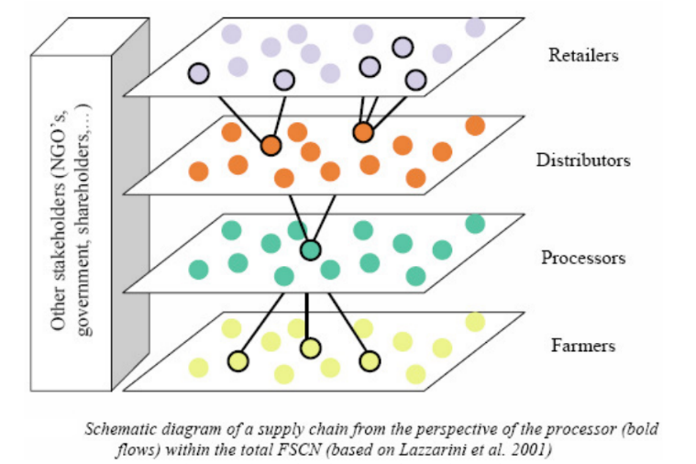3.1 **Agriculture supply chain system**

An agriculture supply chain system comprises cooperatives that are responsible for the production and distribution of vegetable, fruits, cereals, pulses or animal-based products.

In a general sense, this chain includes agricultural activities, food processing, distribution and consumption as primary links. At the secondary level, the stakeholder community comprises of communities such as feedstock suppliers, agro-chemical manufacturers, food packaging industries, machinery and equipment manufacturers, food processors, and waste processers. These groups do not participate directly in the primary supply chain network line but play a very important side role by assisting the main players in the chain.

The following table depicts the roles of various stakeholders at different stages:

|  |  |  |
| --- | --- | --- |
| Stage | Stakeholders involved | Products and role |
| Raw Material Production | Farming input suppliers | * Seeds * Manufacturers - fertilizers, pesticides, agro-Chemicals, farming equipment * Supplier - Water Suppliers, livestock feed suppliers, * Service providers - veterinary |
| Type of farmers | Livestock breeders, Poultry farmers, Horticulture farmers, Arable, pastoral etc. |
| Processing Stages | Food processors | Dairy products, grain millers, frozen foods, bottled drinks, canned foods, hydrated, powdered, raw, baked, roasted, preserved, confectionary etc. |
| Warehouses and wholesale traders | These products are stored into warehouses owned by either the processor or any other private stakeholder who may be a mediatory wholesaler |
| Distribution and Consumption | Transport | Logistics play a major role in the distribution of the products at a global level. |
| Retailers | Includes:  Grocery shops, supermarkets, milkmen, bakeries, vegetable market traders, butcheries, fruit market traders |
| Consumers | Family households, other small traders, farmers, all age group people. |

All the major stakeholders are mutually dependent on each other and most important thing which matters is the quality of service which is provided by the up line (*up line – stakeholders above a particular level). Thus, the price offered at every level of a supply chain is directly proportional to the quality served. Thus, we are able to establish a direct connection between the Farmer and the consumer as the price offered to the consumer at final stage will depend upon the health of product which is determined by quality of seeds used, amount of chemicals used, pesticide application, proper water supply, winnowing, drying and storage conditions(ventilation, temperature, humidity) etc.

It proves to be very obvious that a farmer with better inputs and quality control will serve as a base for the success of the overall value chain. This will enrich the values in every community to work to their best potential to earn the best profits. The concept of work and grow together suitably applies here. Hence further, we need to focus on something which is called– A Farmer's Work. Farmers should realize their importance and role as the Starters of the food chain. They should be made well aware of modern technologies and the role of acquiring information in adopting high-quality standards.

3.2 **ICT in Agriculture: A Major Stakeholder**

The use of Information and communication technology includes devices,networks, servers, mobiles, applications guide, monitor and control different processes and systems within agriculture. cation technologies involve

Communication technology involves the extensive use of radio and satellite technologies for remote viewing and monitoring farming activities and crop conditions.

In the last few decades, India has made herself stand among the top 3 countries for becoming the largest producer of various agricultural commodities like paddy, wheat, pulses, groundnut, rapeseed, fruits, vegetables, sugarcane tea, cotton, tobacco leaves etc. according to reports (Govt. Of India, 2008-09). The food grain production rose from 51 Million Tonnes in (1950-51) to 122 Million lot Tones from 122 Million hectares.

in spite of the tremendous growth, in recent years, Agriculture sector has faced a lot of challenges in increasing the production in response to the increasing demand from the growing population. This situation signifies that there is a need for advancement and proper implementation of the existing technology in order to fulfill the expectations of farmers and consumers. This cannot be possible without the inevitable use of ICT in the farming practices carried out in a developing country like India.

Population increasing by 1.4% annually is putting a pressure on natural resources such as land and water to produce more food. Moreover, rising incomes of an average Indian demand the requirement to grow more high-value food in comparison with other crops.

As like the Green revolution, ICT must come in its most massive form to assist the ongoing agriculture practices which tend to make it a valuable stakeholder community in the crop business. Not involved in the main supply chain but assisting each and every division to make their work happen.

As described earlier, we know the importance of the transport sector in each and every supply chain network. In food supply systems, transports should be used in a way such that the goods may be transported in the safest way possible without affecting the quality and without any damage.

Apart from the necessary roads and vehicles, is also important not only a fast way of transport but also an efficient and continuous supply.

It is important to take into account aspects such as: standards and regulations for transportation (mainly hygiene and health conditions) - storage life of the product - temperature conditions - humidity conditions - specific heat - possible chilling injuries to the product - mixed loads - ventilation - sensitivity to foreign odours - loading and unloading procedures - important aspects of insurance including information on the necessary procedures in case of transport damage.

In such a condition, Ariel vehicles may play an important part as a mode of fast and efficient logistic system solutions. But, they have a use in long-distance transport on a global level. Ships are equally preferable. But the major drawback of their application is the limited payload they are able to carry.

*But, what is the solution for short distance efficient transport within a confined area??*

*In 2016, the White House estimated that drones and other UAVs – unmanned aerial vehicles – could result in up to $82 billion worth of economic growth and generate 100,000 jobs by 2025.1 Lately, supply chain management solutions such as using drones for parcel delivery are getting major attention as companies make strides to test and improve the technology.*

As inspired by the above statement, many organizations are beginning to adopt drone technologies in their supply systems at a small level. For example, UAV can ship inventory between different departments within a plant and as a replacement for forklifts and can be used for the delivery purpose in the commercial sector. This will not only save time But also a huge space is optimized for other tasks.

Coming upon the Agriculture sector, UAVs are used to inspect plant health, photo-log plant growth, and map crop yields. Drones are also testing the soil to help optimize water content and fertilizer usage, with the intent of improving crop yields.

1. **Results**

There is an emerging ecosystem of digital technologies in Indian Agriculture. New start-ups and young entrepreneurial firms have started rising and are often attracted by the agriculture sector of India. As most of the large investors, leading it companies and young investors are involving themselves in this sector, ht ecosystem for technology and digital solutions is expanding at an impressive pace. The agriculture market of India is expected to see an annual growth rate of 18.29% until 2022.

Majority of the start-ups are having an aim of developing urban-centric solutions but are not inclined towards the rural sector. They cater to urban demand and are explicitly makinga working on ideas that seem to serve the urban tech world to flourish. Very few of them are making themselves valuable stakeholders of the rural agricultural systems. Those who are involved in agro-based start-ups must have realized the worth of technology in the futuristic development of agricultural related technologies in India.

The agro-tech start-up ecosystem in India has been receiving renewed interest from investors, and an estimated 34 ventures received US$295 million in investments in 2016 in the country—the highest investment amount recorded in India in the past three years as 53 Indian start-ups raised US$313 million.

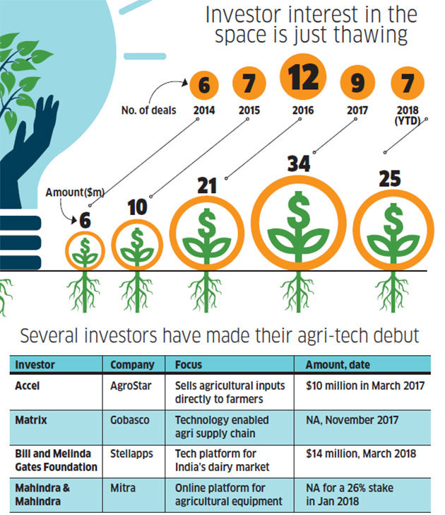"Agri tech is a totally different ball game from urban-centric models that have dominated the headlines,” says Dev Bajaj, the founder of Kissan Mobile which is a mobile-based software for farmers enabling them to resolve their queries and get tips and tricks. Em3, founded in Sep. 2016, a taxi service for agri equipment claims to do a gear task 60% cheaper than a manual alternative. Stellapps, another startup by Ranjith Mukundan, provides IOT solutions to dairies and poultry farms track and improve the productivity of animals and machines. Incubated at IIT Madras, the startup was invested by the Bill and Melinda Gates Foundation in March 2018. Another such noteworthy venture, eKutir Global, offers an online and mobile-based platform to connect marginal farmers with stakeholders across the value chain such as soil-testing labs, suppliers of seeds and fertilizers, banks, exporters, food-processing units, and branded retailers. Several other start-ups related to more advanced technologies have been increasingly established in accordance with the present state of the Indian agricultural model.

1. **Conclusion**

After the globalization, India was able to hold substantial growth and has achieved a certain height in the field of agriculture. But this was all due to the long-lasting effect of the earlier technological revolutions and slowly these efforts lost momentum over time. As we all know that till today, India proves to be one of the major exporters of many of the agricultural commodities which more or less is the result of the input of more than 50% of India’s Workforce. The overall consequence is good but it is adversely affecting the other sectors contributing to GDP. Due to such worse management of efficient human resource. In order to boost our Indian Economy, there needs to be a shift in the jobs of this large community from the agriculture sector to other sectors so that human resource is not wasted rather utilized. This can only be done when there is someone who can replace the existing work of those people which is very necessary for the initial phases of the shift; and here comeszz the role of ICT in agriculture. The use of advanced technologies and automated systems will not only make the agricultural processes more efficient and faster but also encourage the young generation human workforce to participate and involve themselves in the industrial sector. To a large extent, the effort towards this transformation has been catalyzed by the government's special programme on start-ups, Startup India launched in 2016. Many of the large companies have also come forward to support and mentor the small scale startups which tend to encourage the concept of modern agriculture.